Name: Ryan Peters Collaborators: Nicole Joseph

R Lab 4: Distributions

On Your Own:
1) Now let’s consider some of the other variables in the body dimensions data set. Using the figures at the end of the exercises, match the histogram to its normal probability plot. All of the variables have been standardized (first subtract the mean, then divide by the standard deviation), so the units won’t be of any help. If you are uncertain based on these figures, generate the plots in R to check.
For all answers to question 1, see Figure 1, and Figure 2, at the bottom of the document.
a. The histogram for female biiliac (pelvic) diameter (bii.di) belongs to normal probability plot letter ____.
The bii.di data set corresponds to the Normal Q-Q Plot B.
b. The histogram for female elbow diameter (elb.di) belongs to normal probability plot letter ____.
The elb.di data set corresponds to the Normal Q-Q Plot C
c. The histogram for general age (age) belongs to normal probability plot letter ____.
The age data set corresponds to the Normal Q-Q Plot D
d. The histogram for female chest depth (che.de) belongs to normal probability plot letter ____.
The che.de data set corresponds to the Normal Q-Q Plot A

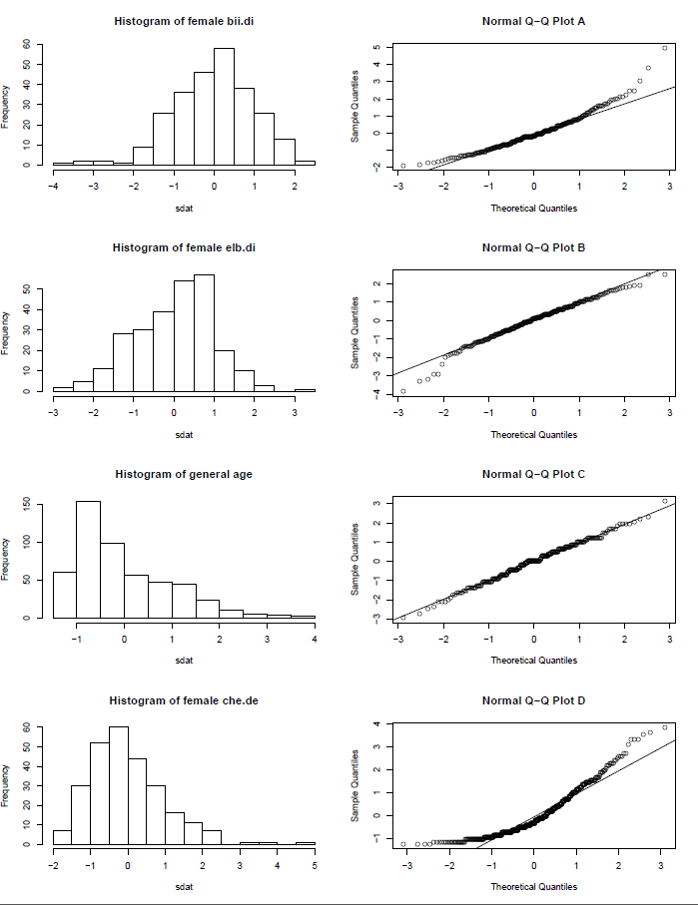

2) Note that normal probability plots C and D have a slight stepwise pattern.
Why do you think this is the case?

The apparent benching in the normal Q-Q plots is probably the result of large subgroups in the data sample sharing a common value.

3) As you can see, normal probability plots can be used both to assess normality and visualize skewness. Make a normal probability plot for female knee diameter (kne.di). Based on this normal probability plot, is this variable left skewed, symmetric, or right skewed? Use a histogram to confirm your findings.

See figure 2 for my diagrams.
The figure appears to indicate a right skew in the normal Q-Q plot. As the data points get further and further apart, and as their difference from the mean grows in standard deviations, they should become further and further from the line representing a true normal distribution on the data set’s mean and standard dev. These are all traits the data shows in my figure 2.
The histogram confirms this, as it shows the data having a gradual taper to the right as outlier values become further spread apart.

Figure 1
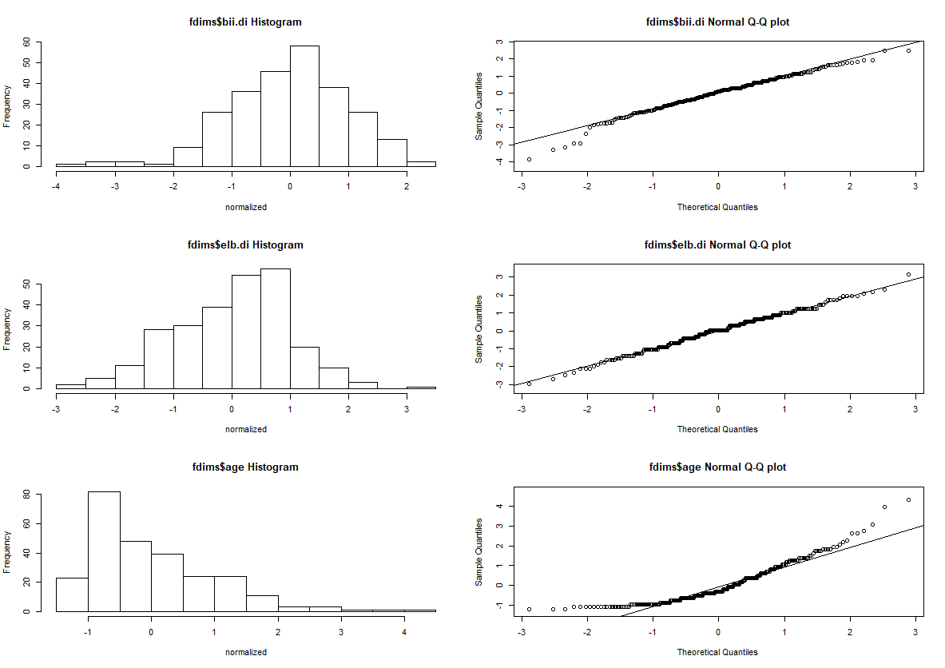
Figure 2
